**Industrial visit prasada processing unit**

**Introduction:**

Dharmasthala is a town in the southwest Indian state of Karnataka. The centuries-old Sri Manjunatha Temple, dedicated to Lord Shiva, is a place of Hindu pilgrimage known for its large statue of the revered figure Bahubali. The Manjusha Museum's eclectic collection includes manuscripts and early wooden chariots. Nearby, the Car Museum features vintage automobiles, including a 1920s Studebaker used by Mahatma Gandhi.

**Introduction for prasada packing unit:**

**Division:**

* Theertha
* panchakajjaya
* Dry kishmish, sugar
* Bella kayi

**Theertha preparing unit:**

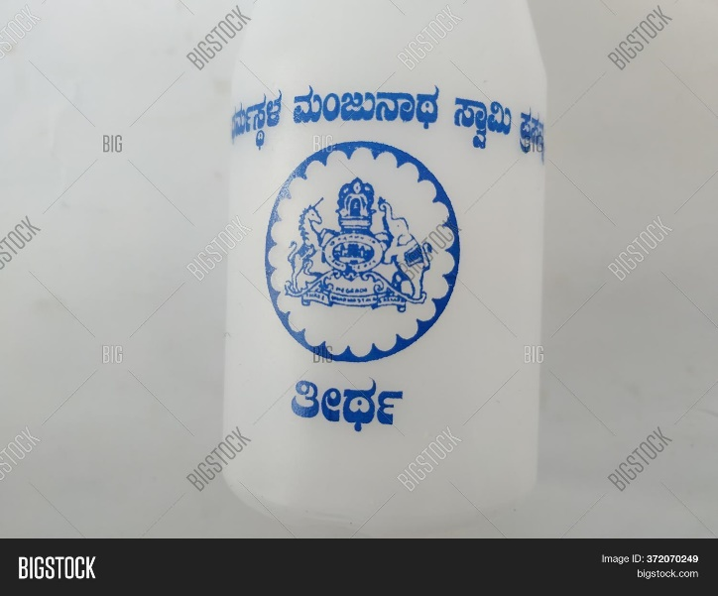

Closeup of blue colour shri Dharmasthala Manjunatheshwara, Sri prasada Teertha Bottle isolated in a white colour background

**Panchakajjaya preparing unit:**

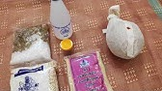

Panchakajjaya is prepared using gram dal, sugar, coconut, ghee and cashews is very easy and sweet. Dry roast the gram dal in a big machine transfer it a grind and grind into a sugar ,coconut, ghee, cashews and panchakajjaya is ready next packing the panchakajjaya in automatically.

**Dry kishmish, sugar preparing unit:**



**Here we can**

**Coconut Burfi sweet:**